Experiment No: 4

Title: Use function types, scope, and closures; apply try-catch; build a palindrome checker.

Software/Tools Required: Visual Studio Code (or any text editor), Web Browser (Google Chrome, Microsoft Edge, Firefox, etc.)

Theory:
JavaScript Functions
Functions are reusable blocks of code designed to perform a specific task. JavaScript supports different types of functions:
- Function Declaration: A named function that can be called before its definition due to hoisting.
- Function Expression: A function assigned to a variable, executed only after initialization.
- Arrow Function: A concise ES6 syntax for writing functions, especially useful for callbacks and short functions.
Variable Scope
Scope determines where variables can be accessed.
- Global Scope: Variables declared outside functions are accessible throughout the program.
- Function Scope: Variables declared using var inside a function are accessible only within that function.
- Block Scope: Variables declared with let and const are limited to the block ({}) in which they are defined.
Closures
A closure is created when an inner function retains access to the variables of its outer function even after the outer function has finished execution. Closures are commonly used for data
encapsulation, private variables, and maintaining state.

Exception Handling (try-catch)
The try-catch statement allows JavaScript programs to handle runtime errors gracefully. The try block contains code that may generate an error, while the catch block executes if an
exception occurs, preventing the application from crashing.

Experiment Context
This experiment involves creating an interactive Palindrome Checker. The application accepts a string from the user and determines whether it is a palindrome. It demonstrates different function types for processing input, uses variable scope effectively, implements
closures to preserve internal state, and applies try-catch to handle invalid or unexpected user input.

Output:

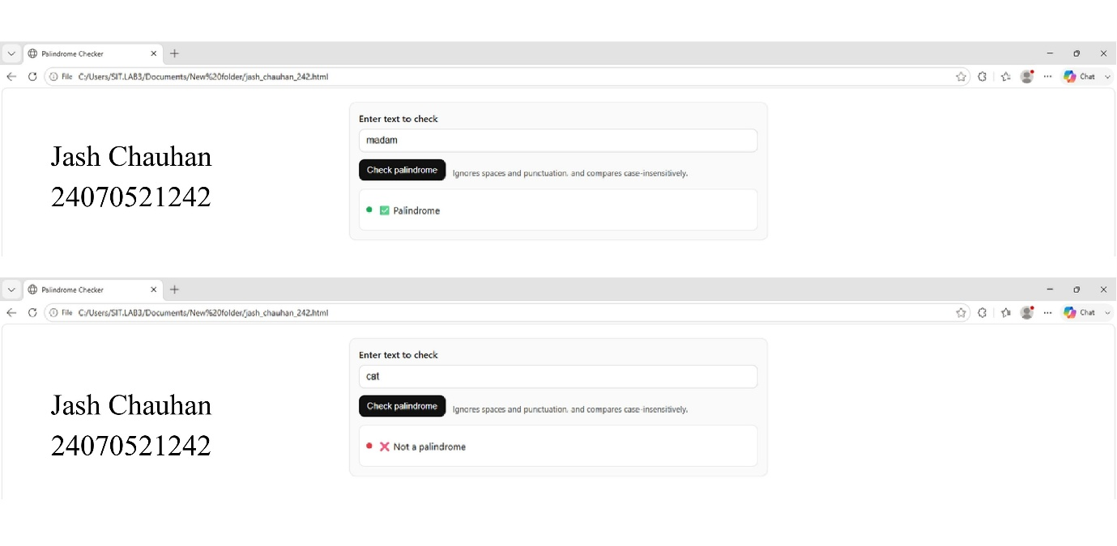

Result/Conclusion:
The experiment was performed successfully. Different types of JavaScript functions, variable scope, closures, and exception handling using try-catch were implemented. A Palindrome Checker was also developed, which correctly identifies whether the given input is a palindrome or not.

